Задание №11
Цыпышев Тимофей, ИУ5-61Б

Порядок выполнения работы:
Открыть GPSS World. Открыть каталог моделей-Samples.
1) Открыть и изучить работу модели Periodic.GPS, выполнив ее командой START 60
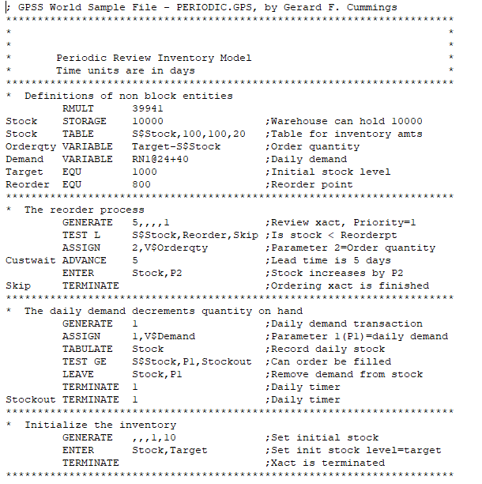
Результат:
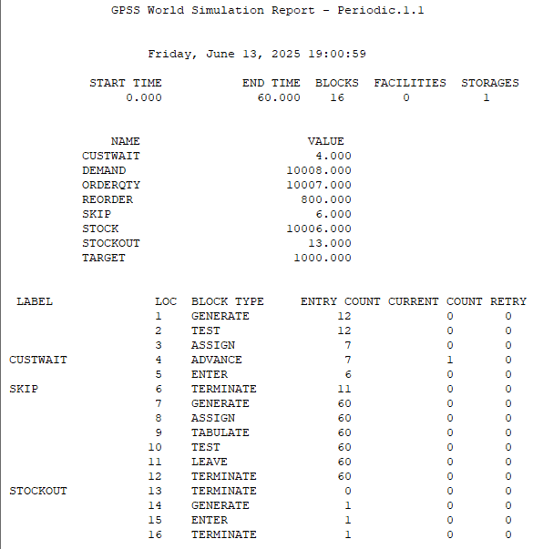
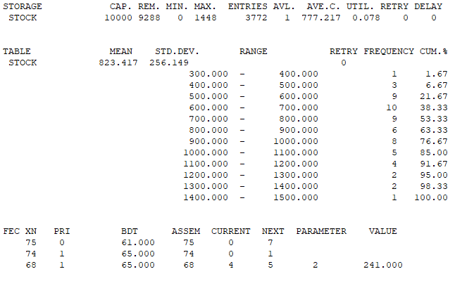
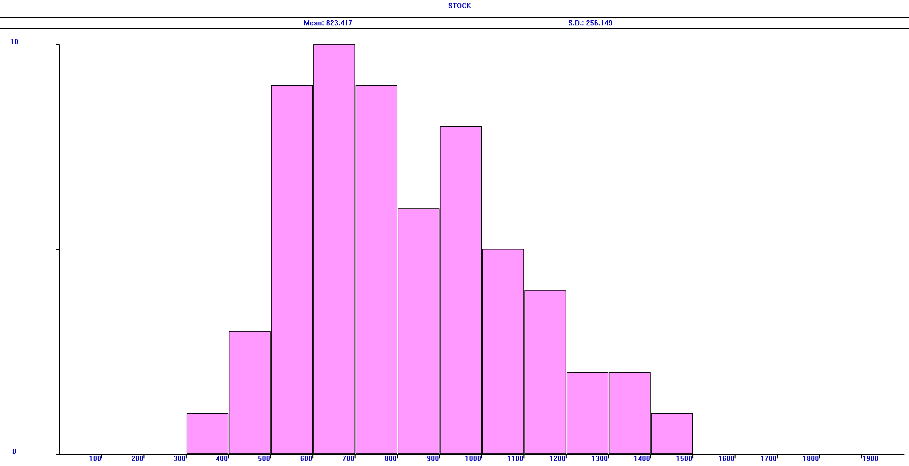
2) Открыть и изучить работу модели SCHR4B.GPS, выполнив ее командой START 1
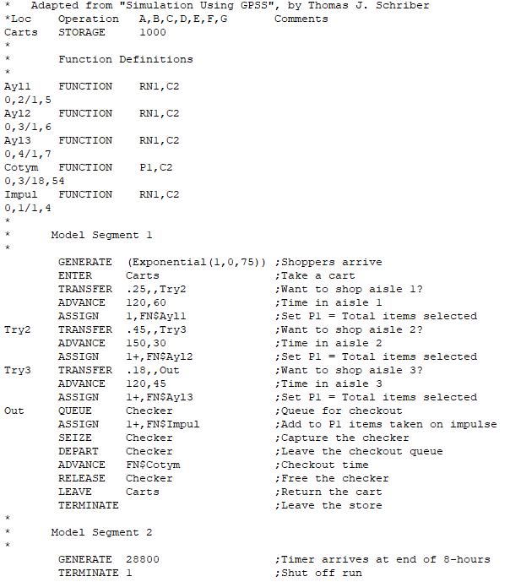
Результат:
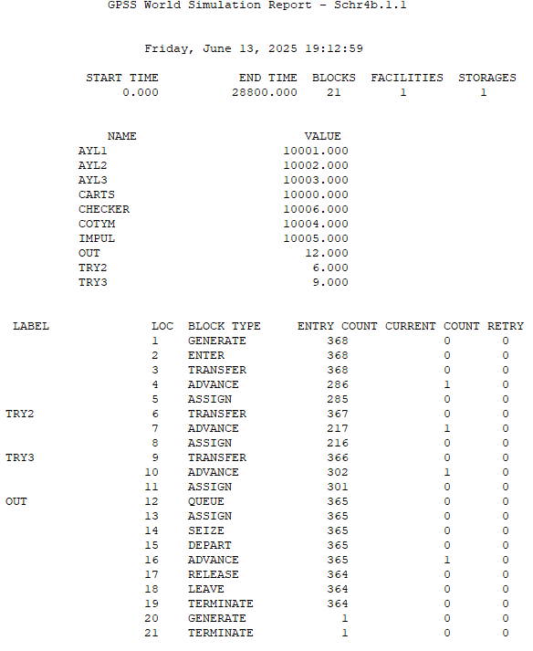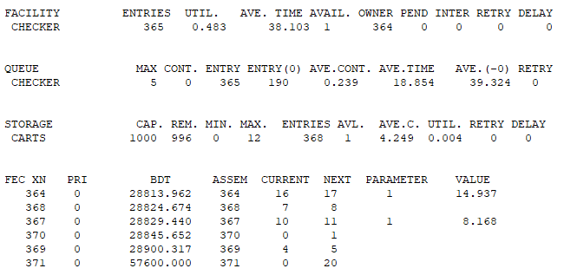
3) Открыть и изучить работу модели Stockctl.GPS, выполнив ее командой START 52
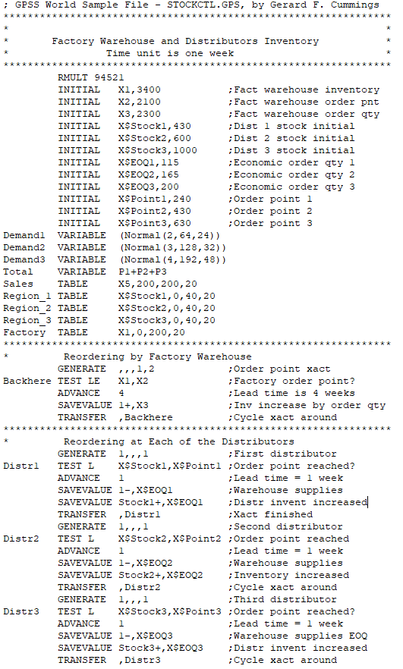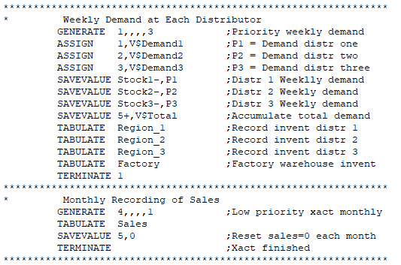
Результат:
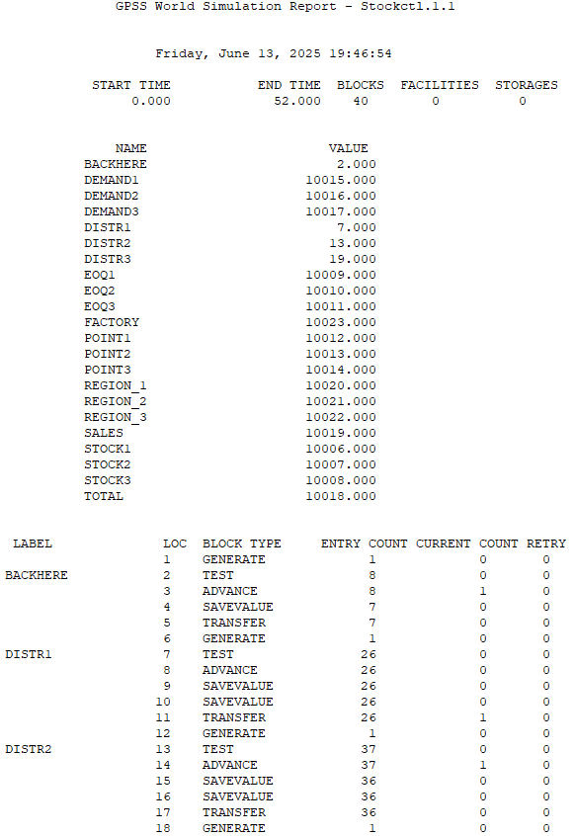
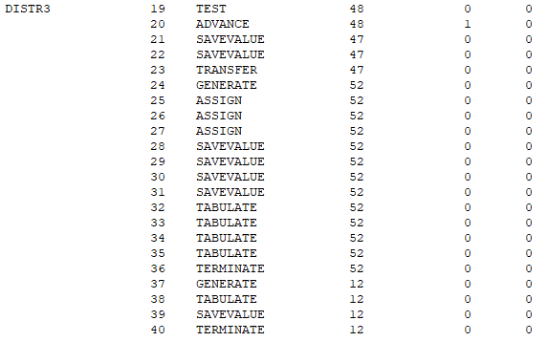
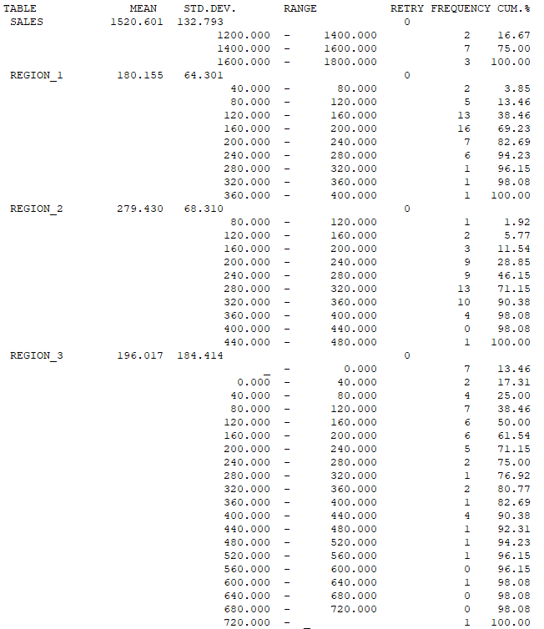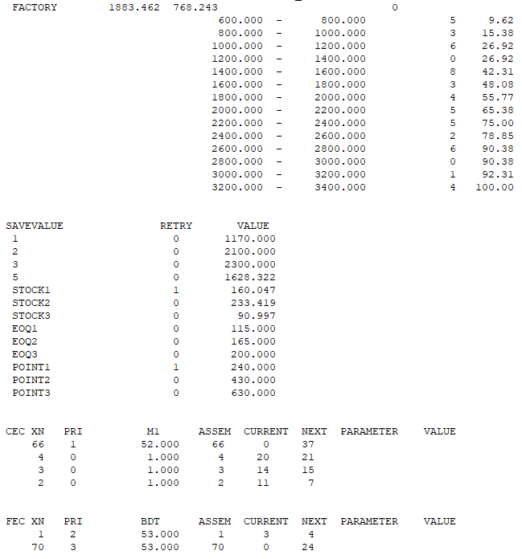
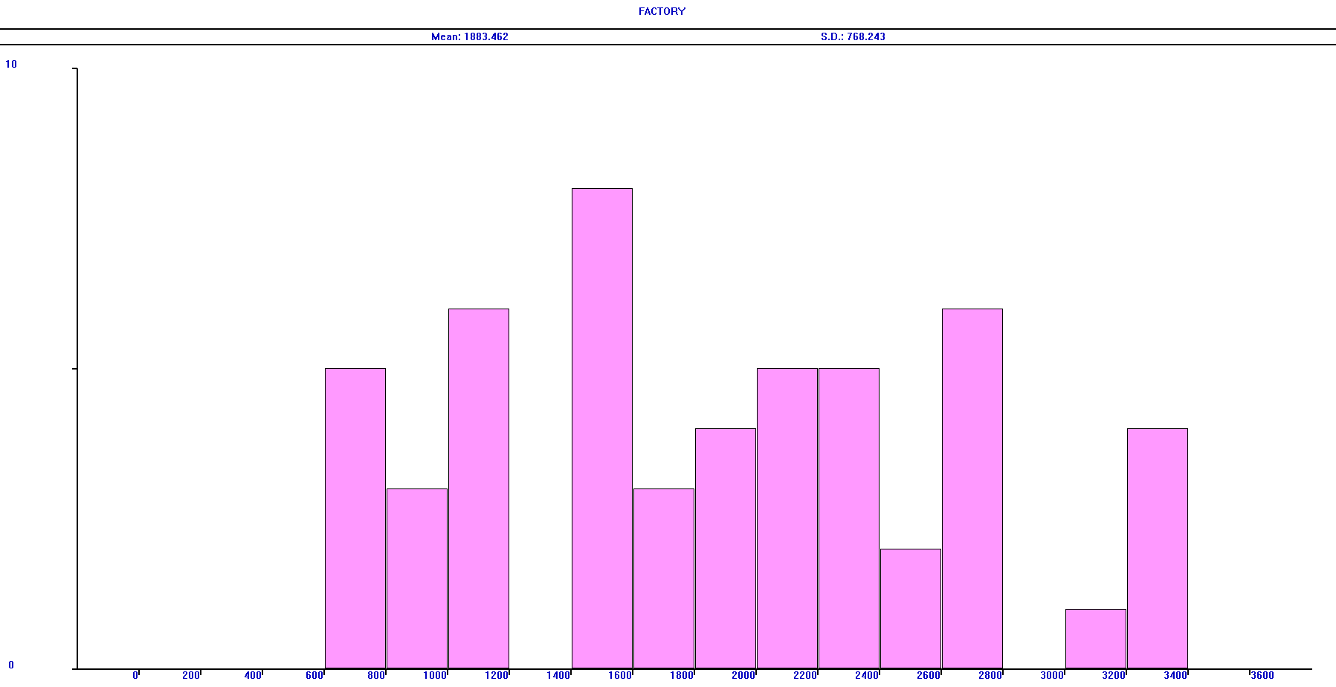
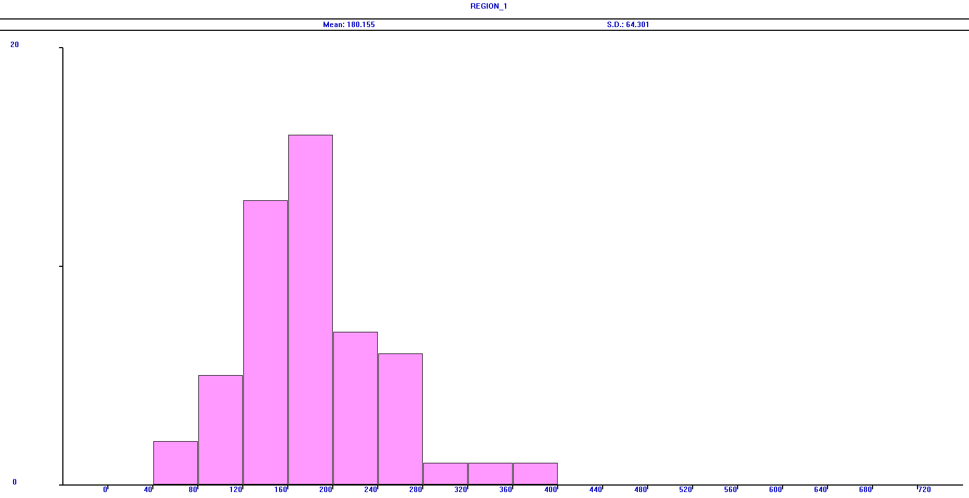
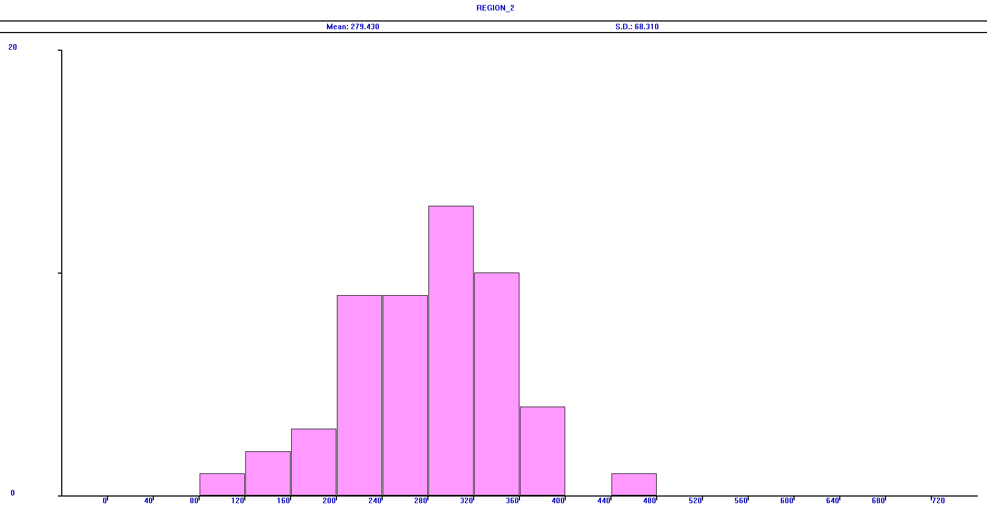
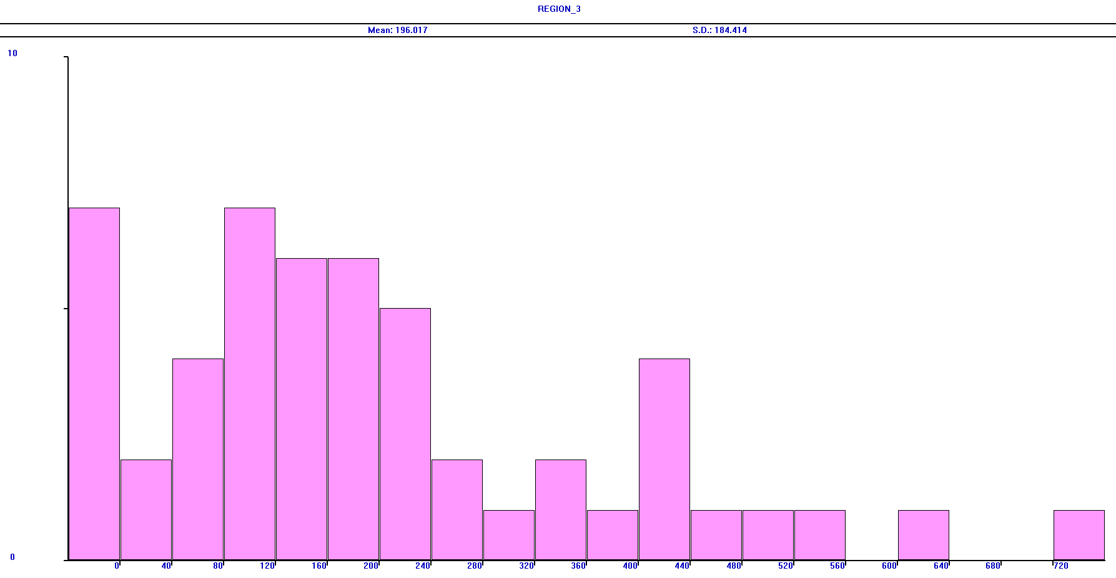
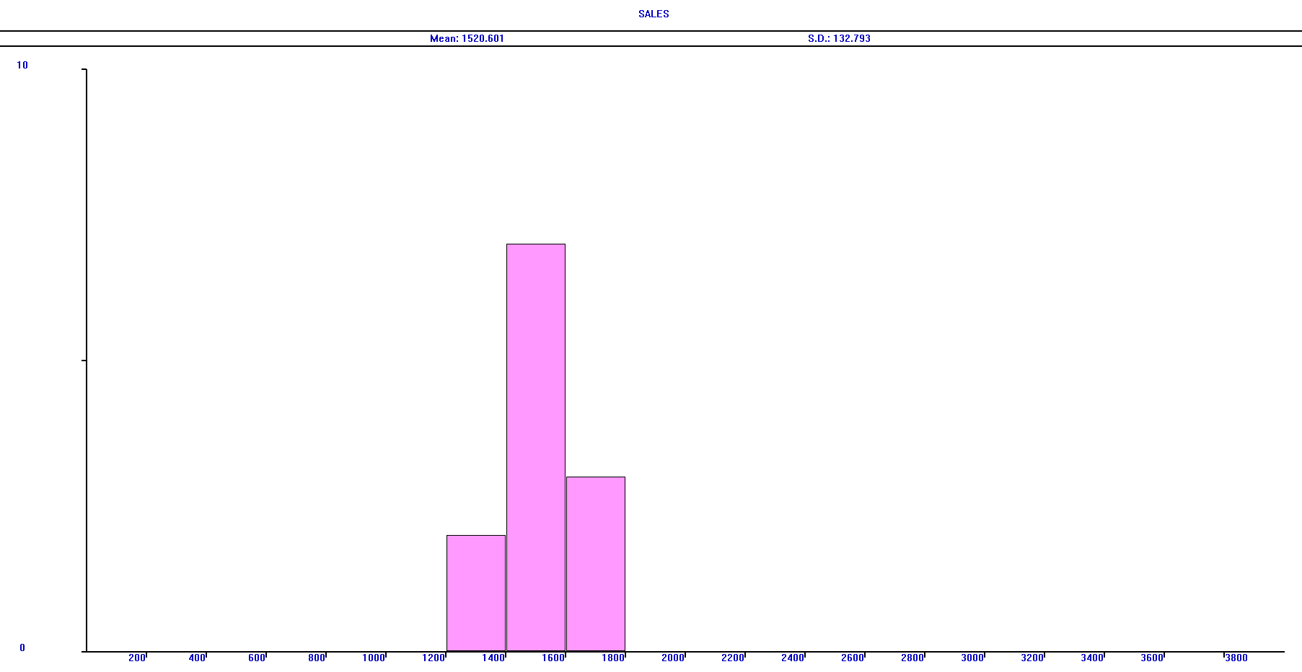
4) На основе данных из примера Stockctl.gps сделайте модель движения складских запасов на фабрике и на филиалах. Необходимо составить модель, в которой используются объекты storage. За единицу времени следует принять 1 день. Необходимо построить диаграммы изменения складских запасов для всех четырёх складов за один год. Для контроля выполнения заказов добавьте блоки Queue, Depart, QTable.

Код:
; GPSS World Sample File - STOCKCTL.GPS, by Gerard F. Cummings
****************************************************************
* *
* Factory Warehouse and Distributors Inventory *
* Time unit is one week *
****************************************************************
RMULT 94521
INITIAL X1,3400 ;Fact warehouse inventory
INITIAL X2,2100 ;Fact warehouse order pnt
INITIAL X3,2300 ;Fact warehouse order qty
INITIAL X$Stock1,430 ;Dist 1 stock initial
INITIAL X$Stock2,600 ;Dist 2 stock initial
INITIAL X$Stock3,1000 ;Dist 3 stock initial
INITIAL X$EOQ1,115 ;Economic order qty 1
INITIAL X$EOQ2,165 ;Economic order qty 2
INITIAL X$EOQ3,240 ;Economic order qty 3
INITIAL X$Point1,240 ;Order point 1
INITIAL X$Point2,430 ;Order point 2
INITIAL X$Point3,630 ;Order point 3
Demand1 VARIABLE (ABS(Normal(2,64,24)))
Demand2 VARIABLE (Normal(3,128,32))
Demand3 VARIABLE (Normal(4,192,48))
Total VARIABLE P1+P2+P3

Stock1 storage 500
Stock2 storage 700
Stock3 storage 1100
StockF storage 4000

Sales TABLE X5,200,200,20
Region_1 TABLE X$Stock1,0,40,20
Region_2 TABLE X$Stock2,0,40,20
Region_3 TABLE X$Stock3,0,40,20
Factory TABLE X1,0,200,20
****************************************************************
* Reordering by Factory Warehouse
GENERATE ,,,1,2 ;Order point xact
Backhere TEST LE S$stockF,X2 ;Factory order point?
ADVANCE 4 ;Lead time is 4 weeks
; SAVEVALUE 1+,X3 ;Inv increase by order qty
enter stockF,X3
TRANSFER ,Backhere ;Cycle xact around
****************************************************************
* Reordering at Each of the Distributors
GENERATE 1,,,1 ;First distributor
Distr1 TEST L S$Stock1,X$Point1 ;Order point reached?
ADVANCE 1 ;Lead time = 1 week
; SAVEVALUE 1-,X$EOQ1 ;Warehouse supplies
; SAVEVALUE Stock1+,X$EOQ1 ;Distr invent increased
leave stockF,X$EOQ1
enter stock1,X$EOQ1
TRANSFER ,Distr1 ;Xact finished
GENERATE 1,,,1 ;Second distributor
Distr2 TEST L S$Stock2,X$Point2 ;Order point reached
ADVANCE 1 ;Lead time = 1 week
; SAVEVALUE 1-,X$EOQ2 ;Warehouse supplies
; SAVEVALUE Stock2+,X$EOQ2 ;Inventory increased
leave stockF,X$EOQ2
enter stock2,X$EOQ2
TRANSFER ,Distr2 ;Cycle xact around
GENERATE 1,,,1 ;Third distributor
Distr3 TEST L S$Stock3,X$Point3 ;Order point reached?
ADVANCE 1 ;Lead time = 1 week
; SAVEVALUE 1-,X$EOQ3 ;Warehouse supplies EOQ
; SAVEVALUE Stock3+,X$EOQ3 ;Distr invent increased
leave stockF,X$EOQ3
enter stock3,X$EOQ3
TRANSFER ,Distr3 ;Cycle xact around
****************************************************************
* Weekly Demand at Each Distributor
GENERATE 1,,3,,3 ;Priority weekly demand
ASSIGN 1,V$Demand1 ;P1 = Demand distr one
ASSIGN 2,V$Demand2 ;P2 = Demand distr two
ASSIGN 3,V$Demand3 ;P3 = Demand distr three
; SAVEVALUE Stock1-,P1 ;Distr 1 Weeklly demand
; SAVEVALUE Stock2-,P2 ;Distr 2 Weekly demand
; SAVEVALUE Stock3-,P3 ;Distr 3 Weekly demand
leave Stock1,P1
leave Stock2,P2
leave Stock3,P3
savevalue 5+,(P1+P2+P3)

; SAVEVALUE 5+,V$Total ;Accumulate total demand
TABULATE Region_1 ;Record invent distr 1
TABULATE Region_2 ;Record invent distr 2
TABULATE Region_3 ;Record invent distr 3
TABULATE Factory ;Factory warehouse invent
TERMINATE 1
****************************************************************
* Monthly Recording of Sales
GENERATE 4,,,,1 ;Low priority xact monthly
TABULATE Sales
SAVEVALUE 5,0 ;Reset sales=0 each month
TERMINATE ;Xact finished
****************************************************************
GENERATE 0,,,1
ENTER stockF,X1
TERMINATE

Результат:
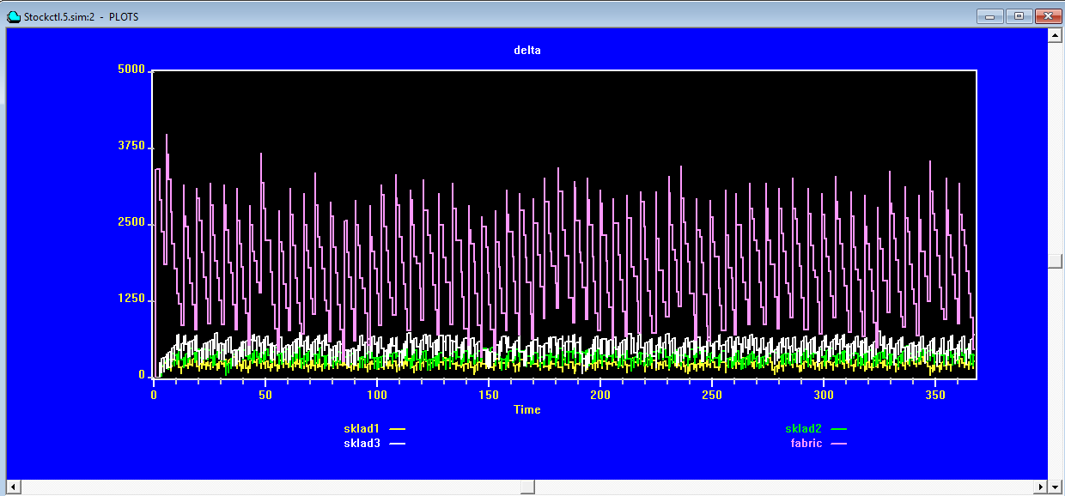
GPSS World Simulation Report - Untitled Model 1.1.1

Friday, June 13, 2025 19:59:42

START TIME END TIME BLOCKS FACILITIES STORAGES
0.000 362.000 43 0 4

NAME VALUE
BACKHERE 2.000
DEMAND1 10015.000
DEMAND2 10016.000
DEMAND3 10017.000
DISTR1 7.000
DISTR2 13.000
DISTR3 19.000
EOQ1 10009.000
EOQ2 10010.000
EOQ3 10011.000
FACTORY 10024.000
POINT1 10012.000
POINT2 10013.000
POINT3 10014.000
REGION_1 10021.000
REGION_2 10022.000
REGION_3 10023.000
SALES 10020.000
STOCK1 10006.000
STOCK2 10007.000
STOCK3 10008.000
STOCKF 10019.000
TOTAL 10018.000

LABEL LOC BLOCK TYPE ENTRY COUNT CURRENT COUNT RETRY
1 GENERATE 1 0 0
BACKHERE 2 TEST 59 0 0
3 ADVANCE 59 0 0
4 ENTER 59 0 0
5 TRANSFER 59 1 0
6 GENERATE 1 0 0
DISTR1 7 TEST 195 0 0
8 ADVANCE 195 0 0
9 LEAVE 195 0 0
10 ENTER 195 0 0
11 TRANSFER 195 1 0
12 GENERATE 1 0 0
DISTR2 13 TEST 285 0 0
14 ADVANCE 285 1 0
15 LEAVE 284 0 0
16 ENTER 284 0 0
17 TRANSFER 284 0 0
18 GENERATE 1 0 0
DISTR3 19 TEST 283 0 0
20 ADVANCE 283 1 0
21 LEAVE 282 0 0
22 ENTER 282 0 0
23 TRANSFER 282 0 0
24 GENERATE 360 0 0
25 ASSIGN 360 0 0
26 ASSIGN 360 0 0
27 ASSIGN 360 0 0
28 LEAVE 360 0 0
29 LEAVE 360 0 0
30 LEAVE 360 0 0
31 SAVEVALUE 360 0 0
32 TABULATE 360 0 0
33 TABULATE 360 0 0
34 TABULATE 360 0 0
35 TABULATE 360 0 0
36 TERMINATE 360 0 0
37 GENERATE 90 0 0
38 TABULATE 90 0 0
39 SAVEVALUE 90 0 0
40 TERMINATE 90 0 0
41 GENERATE 1 0 0
42 ENTER 1 0 0
43 TERMINATE 1 0 0

STORAGE CAP. REM. MIN. MAX. ENTRIES AVL. AVE.C. UTIL. RETRY DELAY
STOCK1 500 302 0 327 22425 1 231.030 0.462 1 0
STOCK2 700 397 0 511 46860 1 378.812 0.541 0 0
STOCK3 1100 880 0 756 67680 1 546.671 0.497 0 0
STOCKF 4000 1865 0 3975 139100 1 1775.414 0.444 1 0

TABLE MEAN STD.DEV. RANGE RETRY FREQUENCY CUM.%
SALES 1510.748 139.443 0
600.000 - 800.000 1 1.11
800.000 - 1000.000 0 1.11
1000.000 - 1200.000 0 1.11
1200.000 - 1400.000 14 16.67
1400.000 - 1600.000 53 75.56
1600.000 - 1800.000 22 100.00
REGION_1 430.000 0.000 0
400.000 - 440.000 360 100.00
REGION_2 600.000 0.000 0
560.000 - 600.000 360 100.00
REGION_3 1000.000 0.000 0
720.000 - _ 360 100.00
FACTORY 3400.000 0.000 0
3200.000 - 3400.000 360 100.00

SAVEVALUE RETRY VALUE
1 0 3400.000
2 1 2100.000
3 0 2300.000
5 0 822.808
STOCK1 0 430.000
STOCK2 0 600.000
STOCK3 0 1000.000
EOQ1 0 115.000
EOQ2 0 165.000
EOQ3 0 240.000
POINT1 1 240.000
POINT2 0 430.000
POINT3 0 630.000

CEC XN PRI M1 ASSEM CURRENT NEXT PARAMETER VALUE
4 0 1.000 4 20 21
3 0 1.000 3 14 15
2 0 1.000 2 11 7

FEC XN PRI BDT ASSEM CURRENT NEXT PARAMETER VALUE
457 3 363.000 457 0 24
455 1 364.000 455 0 37

